2014-SK-01-EN Robot painting
0 hard | I: medium | II: easy | III: ---- | IV: ----

Answer Type: Click to choose! Mandatory for: none

Body

The painter robot created a picture by painting four geometrical shapes, each one on top of the previous ones, in this order:
First it painted a yellow circle,
then a green rectangle,
then a blue square,
and finally a red triangle.

Question

Which picture has the robot created?

Answer

A) 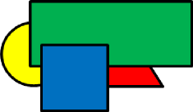 B) 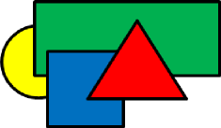
C) 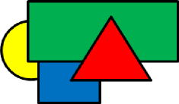 D) 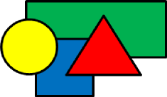

Explanation

The correct answer is B.
The robot paints each next shape on top of the already painted ones. Therefore the yellow circle must be at the very bottom of all shapes. Therefore D cannot be the correct answer. The red triangle must be at the very top of all the shapes, therefore A cannot be the correct answer. And finally, the blue square must be painted on top of the green rectangle and therefore C cannot be the correct answer either.

It's informatics

The order of actions and what happens if a computer or a robot executes the actions in a specific order are among the basic things which informatics deals with.
Moreover, understanding this particular task gives you useful knowledge for using graphical editors.

Keywords

order of actions, use of graphical editor

Websites

Internal Use

Wording

The colors do not play a key role in the task, so if you want to have a strictly color-blind proof task then you can leave the color names out of the text. But then the task may be significantly harder for non color-blind pupils of the group 0.
"Each one on top of previous ones" is important, but it may need care in translation to say it clearly enough for the age group (even when translating to proper English).

Comments

Author, e-mail, Date (YYYY-MM-DD), Comment.

Graphics

All graphics was created by the original author of the task.

Files

2014-SK-01-EN Robot painting.odt (this file)
2014-SK-01_a.svg
2014-SK-01_b.svg
2014-SK-01_c.svg
2014-SK-01_d.svg
2014-SK-01_a.png
2014-SK-01_b.png
2014-SK-01_c.png
2014-SK-01_d.png

Authorship

Monika Gujberová, mgujberova@gmail.com , Slovakia.

License

Copyright © 2014 Bebras – International Contest on Informatics and Computer Fluency. This work is licensed under a Creative Commons Attribution-NonCommercial-ShareAlike 3.0 Unported License (CC BY-NC-SA 3.0). Visit: http://creativecommons.org/licenses/by-sa-sa/3.0/

